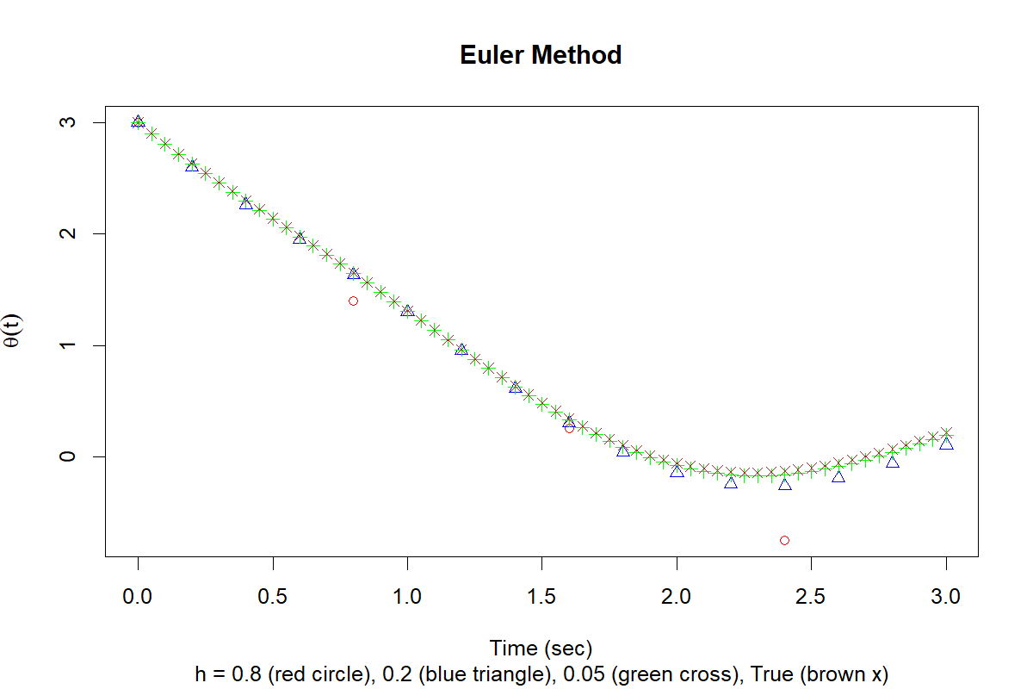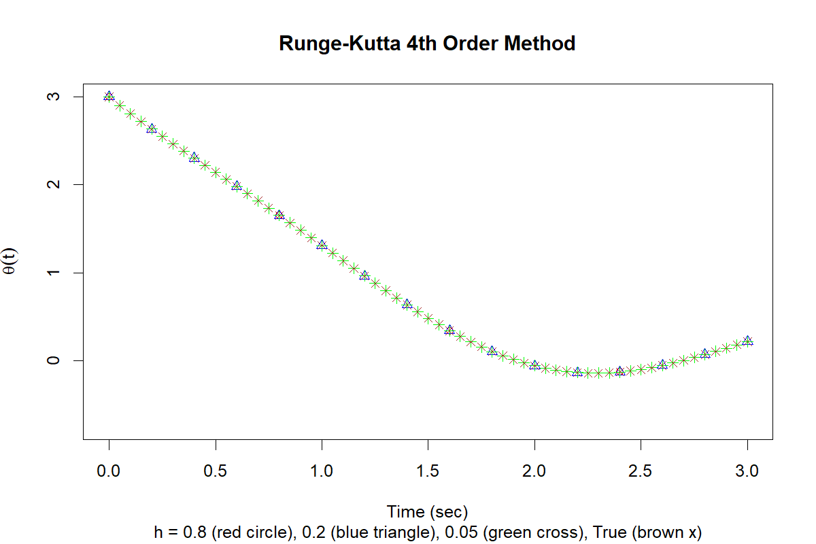

PART-A
- Which method has the highest accuracy?
- The Runge-Kutta 4th order method (RK4) has the highest accuracy.

- Which values for h have the highest accuracy?
- The smallest step size, h = 0.05, has the highest accuracy.

- What evidence exists to support your choices for the previous questions?
- The evidence comes from the percent error values and the graphs. The RK4 method has very small errors compared to Euler’s method, which shows it is more accurate. Also, when the step size gets smaller, the errors become much smaller. In the graphs, RK4 points are very close to the true solution, while Euler points are farther away, especially for larger h. This proves that RK4 and smaller h give better accuracy.

PART-B

- What is a differential equation?
- A differential equation is an equation that includes a function and its derivative. It shows how a quantity changes with respect to another variable, usually time.

- What makes an ordinary differential equation, ordinary?
- An ordinary differential equation (ODE) is called ordinary because it involves derivatives with respect to only one independent variable.

- What is the purpose of the Runge-Kutta methods of numerical analysis?
- The purpose of the Runge-Kutta methods is to find accurate approximate solutions to differential equations when an exact solution is difficult or impossible to find. They improve accuracy by using multiple calculations within each step instead of just one, like in Euler’s method.

